**Rezising the virtual machine:**

**You can use the following sample PowerShell commands to change the size of a virtual machine**

$vm = Get-AzVM -ResourceGroupName **rg01** -VMName **resizevm01**

$vm.HardwareProfile.VmSize **="Standard_DS1_v2"**

Update-AzVM -VM $vm -ResourceGroupName rg01

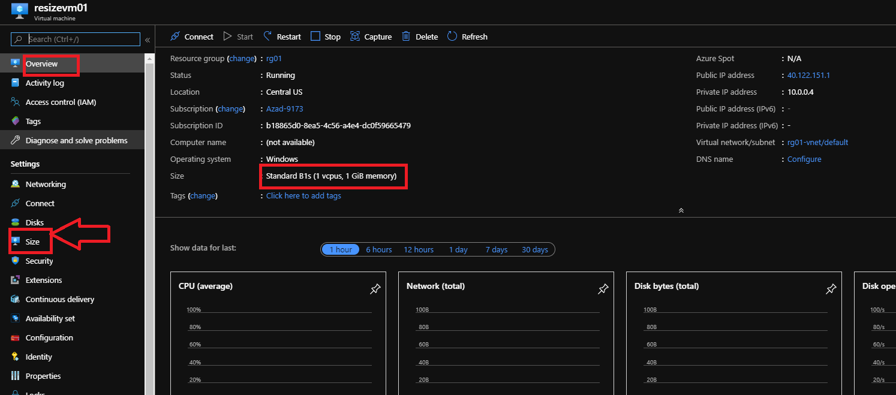

**You can not able to resize without stopping the VM. If you stop the VM public IP will be lost and re-allocate public IP.**

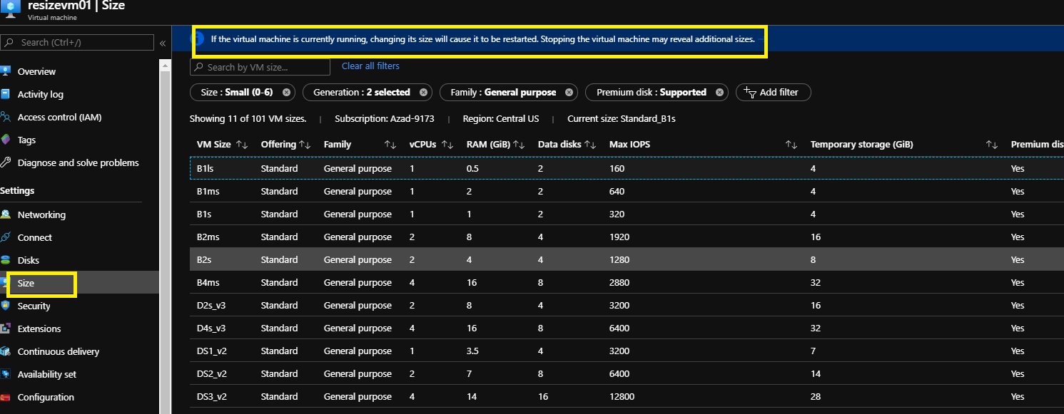

**The VM is resized and Public IP re-allocated.**

